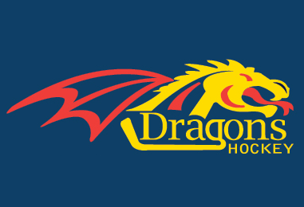
Dorchester Minor Hockey 45th Dave Clarke Memorial Novice Tournament
Registration Application
November 7th – November 9th, 2014

Open to Novice A/BB/B/CC/C/DD/D/AE1/AE2/AE3/AE4/AE5,MD
OMHA Sanction Permit # 8343118

The tournament fee is $775.00, 3 games GUARANTEED (possible 5 games), NO gate fees, and one meal ticket for each player and coaching staff.

Association: ____________________________________________________________
Team name/Classification: _______________________________________________
Sweater colour: Home: _________________ Away: ________________________

CONTACT INFORMATION
COACH:
Name: _______________________________ Phone: _________________________
E-mail:______________________________________________________
Address: _______________________________________________________________

MANAGER:
Name: ________________________________ Phone: ________________________
E-mail:______________________________________________________
Address: _______________________________________________________________

Make cheques payable to: Dorchester Minor Hockey Association. A position will not be held until payment is received. Please return application and roster with payment to:

Mike MacIntyre
53 Turnberry Drive
Dorchester, ON N0L 1G3
Mike.MacIntyre@rogers.com

